Mumbai Junction - the John Lyon
is again threatened with demolition and replacement with an out of scale and unsympathetic block of 42 flats. If you wish to object to the Planning Application No 22/3260 here's how:

The preferred way to object is via Brent's website as below, alternately email planning.comments@brent.gov.uk
https://pa.brent.gov.uk/online-applications/applicationDetails.do?keyVal=DCAPR_161947&activeTab=summary

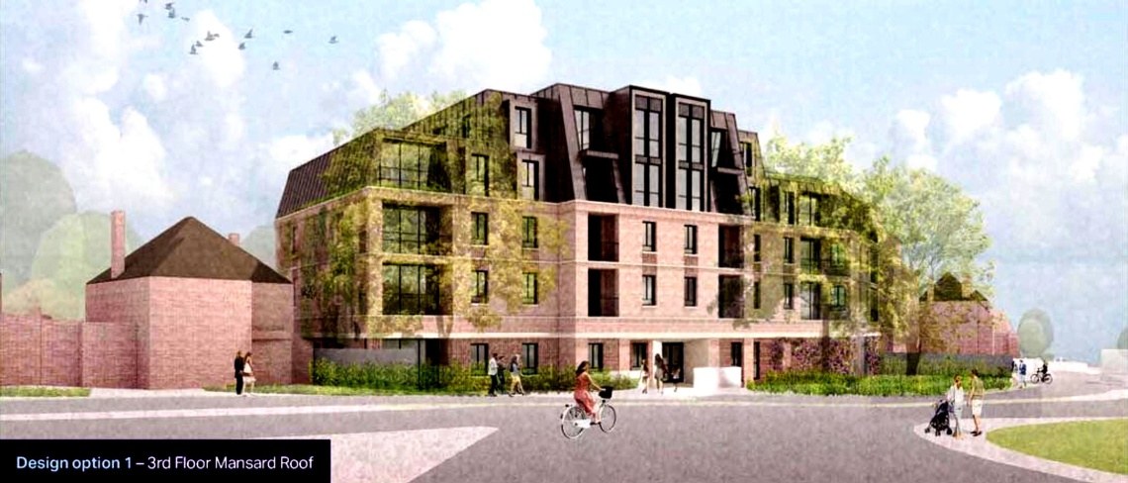
Now click on the View / Make Comments tab, you will need to register and log in to make comments, the button is found at the bottom of the web page. You can then move to making your comments about this application 22/3260. Comments must be received by the 27th October 2022. If require assistance with this email planning@the-scra.co.uk. All the documents regarding the application including this one will be found on the SCRA Website.
The applicant has yet again made the surrounding major roundabout; along with its substantial telecom installation and excessive parking look more like a piazza in some southern European idyllic village. The street trees have become much larger and the relationship to neighbouring properties is hidden other than the swamping of poor 135 Sudbury Court Drive who will now have a four storey high wall alongside them.
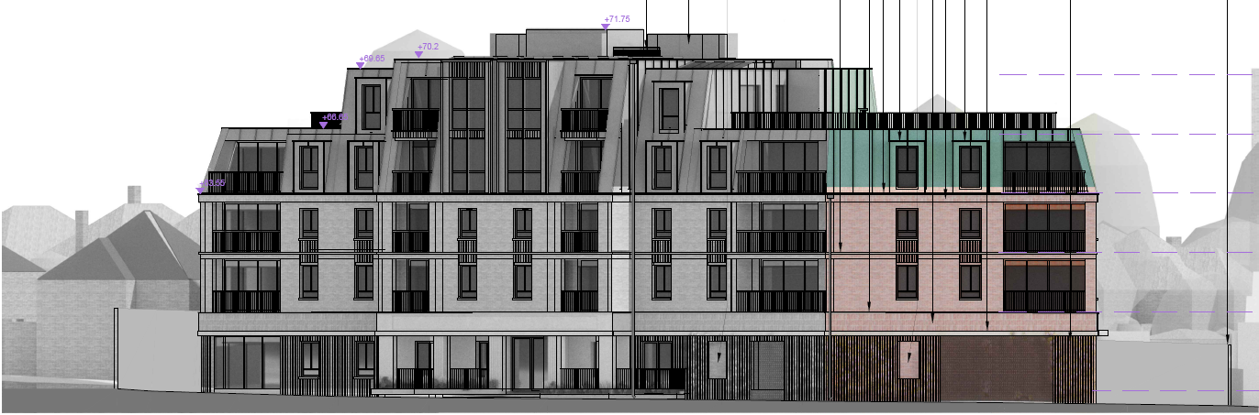
Above is a representation of the proposed building lifted from the Design and Access statement which is almost the same as the East Elevation presented with current application, see below. This is the actual elevation without the artistic licence used above, many may considered it a brutal design and unsympathetic if related to its surroundings.
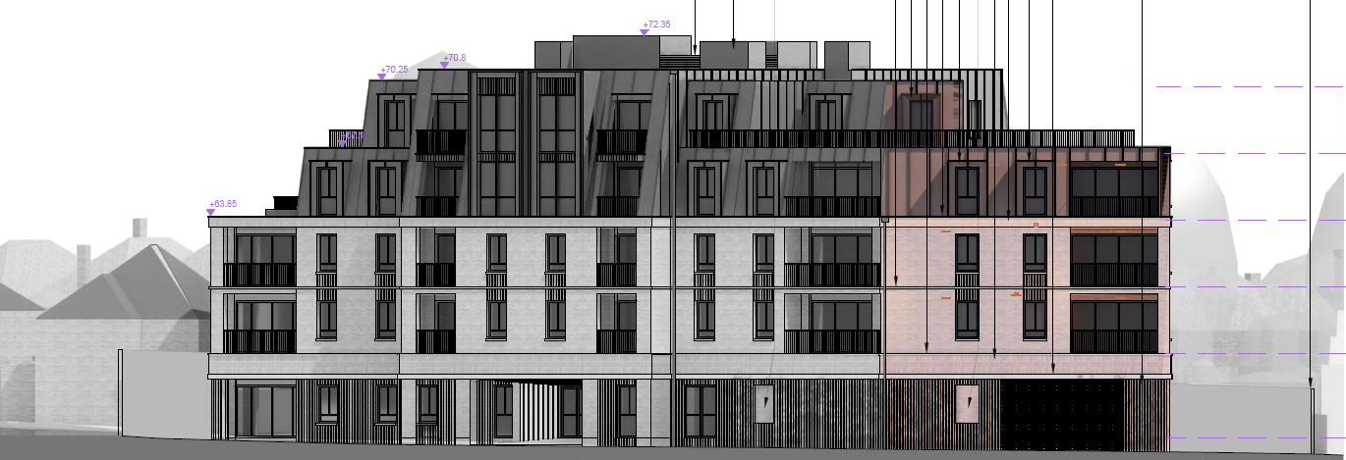
The revised East elevation presented (22/3260 above) seems little different to the 2021 drawing below, there are actually a few amendments which include increased massing to the left side of this East elevation. The building is described as a part 4 and part 5 storey building, however, this doesn't acknowledge the structures on the roof.

A concern that you may wish to express within your objection: The applicant's Planning Statement page 18 states "Following refusal of the 2021 Application, a meeting with Cllr Muhammed Butt (Leader of Brent), Cllr Shama Tatler (Cabinet Member for Regeneration and Planning), Gerry Ansell (Head of Planning and Development Services) and David Glover (Development Manager) took place on 21st June 2022."
The premises are widely known as the John Lyon which has historic significance as John Lyon founded Harrow School some 500 years ago. During the last two decades the hostelry has changed and adapted to the local population's need, it is without doubt a place where everyone can go and it contributes substantively to community cohesion. The loss of this obvious but unregistered Community Asset and meeting point is within easy walking distance of some 3,000 plus homes, its loss would deal a devastating blow to the local community and would force the residents to drive to other destinations further afield. The developer's opinion in the application is that the very small restaurant across the road could somehow replace the John Lyon is bordering on obtuse.

So, how should you phrase your objection to make the biggest impact? There are many different planning policies at play here, however, the SCRA believe the main relevant points, but not exclusively, are:
- The proposal is monolithic in design and size, and without doubt overbearing, it swamps all the surrounding properties, even the two storey shops across the road with dormers in the upper level.
- No Affordable Housing, below standard number of family homes and no property of more than 3 bedrooms.
- There is local consternation at the loss of this large well frequented Public House/Restaurant, which everyone agrees is a valuable Community Asset that enhances community cohesion.
- This 50's Public House sits well in a line of similar style properties from the same era; its removal would damage the consistent architectural theme and heritage.
- The proposal development inflicts great architectural damage and will swamp 135 Sudbury Court Drive.
- The massive unsympathetic building's proximity to, and its prominent position at the Gateway to the Conservation Area (SCCA) will have a detrimental effect on the SCCA as stated by Brent's Heritage Officer.
- The design of the proposed building is locally considered simplistic in the extreme; its height and massing are unacceptable and overbearing. There have been builds of flats in Northwick Park Ward, none of which exceeds three storeys in height and are generally of sympathetic design tenets. One only needs to compare the builds at: East Lane opposite Pasture Road, between Court Parade and Wakeling Lane and Watford Road at the junction with Stilecroft Gardens.
- The local design tenet is extensively two with occasional three storey buildings with pitched and hipped roofs, many employing dormers in the first and second floors. This proposed 4 - 5+ storey building will clash with the local designs such as Tudorbethan, and will without doubt detract from the locales distinctiveness.
- Brent's Planning Policies protect Public Houses; cleverly, as well as running the premises visual condition down, it recently (2019) gained a change of use to a restaurant instead of a protected Public House.
- Play space does not meeting required level, to suggest children cross Watford Road (traffic movements of 30,000 daily) to access parks is obtuse. Amenity space levels are short in some units. No restriction of number of children allowed to use the outdoor play pace at once - see Planning Grant condition for nursery 20/2722.
- Sudbury Court Drive and roundabout floods several times a year as the surface water main is at capacity.
- There is very limited on street parking available in the area during the day and evening as residents will testify, overflow parking from this site may well take the on street parking beyond capacity and damage local trade.
- Access to the site from the north is extremely dangerous and there have been fatal and serious accidents in close proximity. Use of this access from the north should be restricted to compliment the current No U Turns.
- A 7.5 Tonne weight limit has been installed to the service road as damage was being inflicted to parked vehicles, grass verges and street trees. The restriction was designed and sectioned specifically to stop HGV from driving along the service road. Construction traffic will have to use the Sudbury Court Drive access at the entrance to the roundabout, creating a potential accident black-spot.
- Brent's Planning Policies clearly document that the area was designed for motor vehicles and that Public Transport is poor. It is generally accepted locally that the attraction of the area is the unrestricted parking.
- Those living close by have reported seeing bats in their gardens. Bats are a protected species and may well be living and foraging in the development site due to its seclusion and warmth. A building inspection is necessary.
- In Summary: the proposed development by reason of its scale, design, bulk, massing and siting in relation to the suburban context of the site appears as an excessively bulky building which results in a poor transition to the nearby suburban housing and CA. The development has been described as detrimental to the character of the area and the streets scene, contrary to Policy. Also it fails to fully assess the relationship between the proposed building and nearby Conservation Area. We must not forget that there is no Affordable Housing offer. The development is not principally designed for family dwelling which is the area norm, it should be noted that the splitting of a local 5 bedroom property into 2 x 3 bedrooms was recently refused planning.

